1. Which one of the following statements about NullObject design pattern is **NOT** true?

* It is particular case of the strategy pattern in which we choose the strategy of doing nothing.
* Hepls us to implement a default behaviour when you want to deal with an object that is not present at all.
* **We should use sthis pattern instead of null checks.**
* It is commonly used in combination with Singleton pattern.

1. Observer design pattern provides loose coupling as:

* Subject only knows that observer implements Observer interface. Nothing more.
* There is no need to modify Subject to add or remove observers.
* We can reuse subject and observer classes independently of each other.
* **All of above.**

1. Illustration how the ??? pattern can divide the monolithic code of devices and remote controls

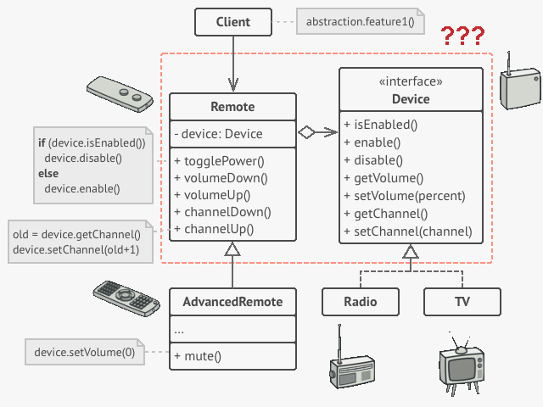

* **Bridge**
* Proxy
* Visitor
* Decorator

1. Which problem is **NOT** solved by Proxy design pattern?

* **How can clients treat an object hierarchy as single object**
* How can the access to an object be controlled
* How can additional functionality be provided when accessing an object
* How can the access to an object be controlled by checking that clients have the required access rights

1. Considering the depicted UML class diagram, which of the following statements are true?

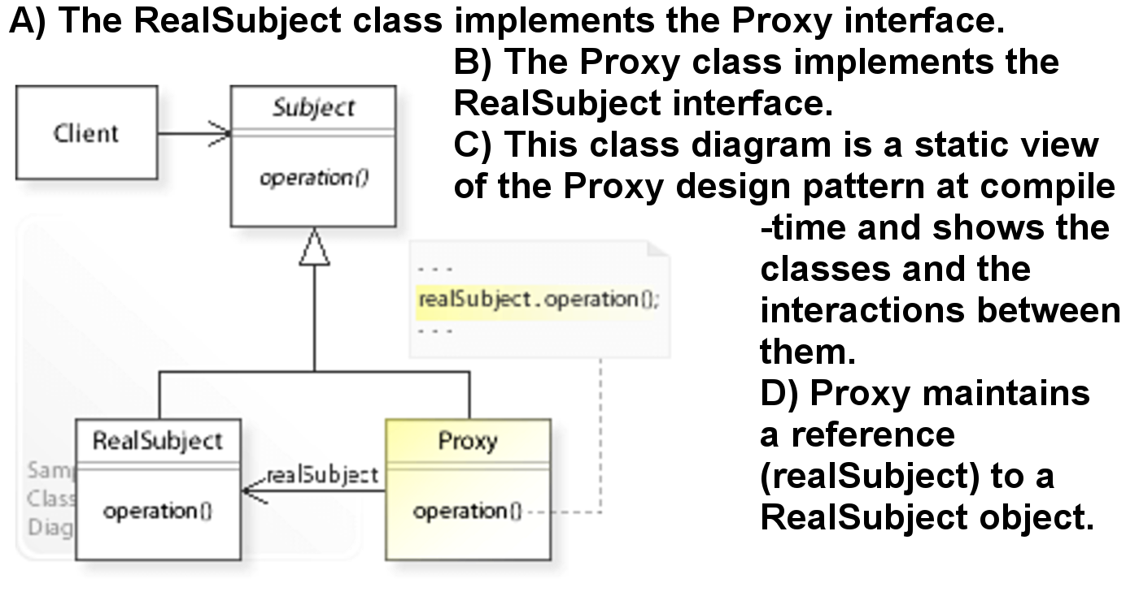

A)

B)

C**)**

**D)**

1. Select the appropriate (sorted) list of design patterns to meet the following requirements:

*1st – wraps an object to provide new behavior.*

*2nd – wraps an object to control access to it.*

*3rd – decouples an abstraction from its implementation so they can vary independently*

* Composite, Visitor, Bridge
* Visitor, Composite, Chain of responsibility
* **Decorator, Proxy, Bridge**
* Decorator, Bridge, Proxy